Credit Name:CSE 2140 2nd Language Programming
Assignment Name: Volume.java
The following questions can help you in thinking critically about your problem-solving processes:
Understanding the Problem
How did you approach understanding the challenge? I understood the challenge by finding that the program needs to take a measurement from three different 3D shapes an find each of their volumes.
Were there any parts of the problem you found confusing at first? If so, how did you resolve that confusion?
The sphere formula was confusing because it used the diameter not the radius. I solved it by using
This code shows that the sphereVolume = (π * d^3)/6
Planning the Solution
Did you create a plan or break the problem into smaller steps before coding?
I did each volume separately and started with the input then process than output for each one.
How did you decide on the tools, data structures, or algorithms to use?
I used Scanner for the input and used input.next.Int() for length,width, height, diameter, and side.
The algorithms, tools and data structures consist of
Implementation
Did you write the code in small pieces or attempt the entire solution at once?
I wrote the code in smaller pieces, I separated it into three groups, rectangular prism, sphere and cube. Every time i finished with a group I tested it and made sure it worked. The image shows how I separated each 3D shape into its own sections.

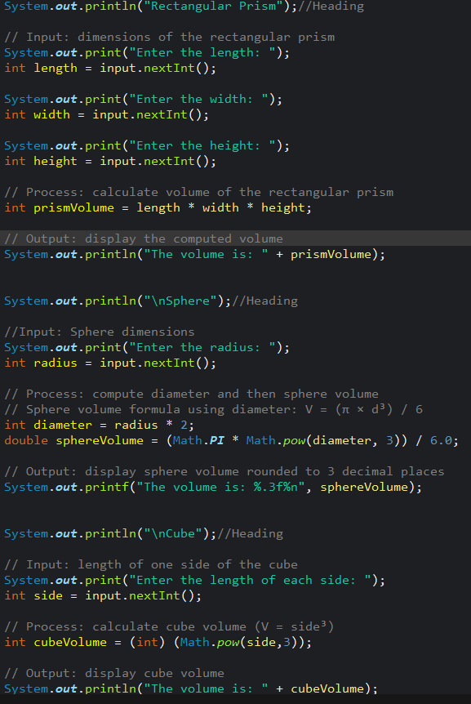
How did you test your solution along the way to make sure it was working?
I tested the program by entering different values for each shape to confirm the formulas worked correctly. For example, I used many different numbers for the presto make sure that the prismVolume = length * width * height actually worked.
Overcoming Challenges
What part of the problem was the most difficult for you?
The most difficult part was figuring out the sphere volume. Having to use the diameter instead of the radius just made it a bit more challenging.
How did you handle moments when you felt stuck or unsure of what to do next?
When I felt stuck I went back over the formulas and tested simple numbers to see if it worked. If it didn’t I changed the formulas and tested with bigger more complex numbers, I repeated this until the code worked.
Learning
Was there anything you learned that you think will help you with future challenges?
I learned how to switch between three different problems and having to use multiple different formulas, algorithms and tools in one code.

